
Mangrove March 2026
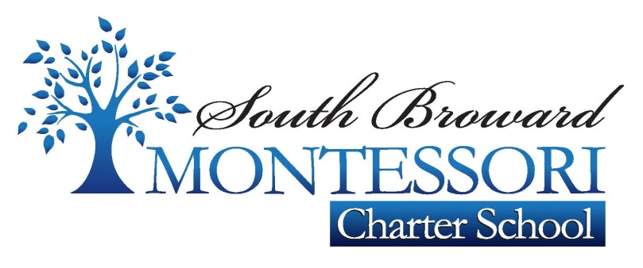 Newsletter


What we are learning
ELA/Reading: This month in ELA, will focus on Text features: Bold print and timelines. Author’s purpose. Character Perspective. Make and confirm predictions. Plot: Beginning, Middle, End. Character Perspective. Text features: graphic Features/Callouts
Vocabulary: We will learn about: Synonyms using primp or online dictionary. Suffixes-full, -les Idioms
Spelling words: Agree, challenging, discover, heroes, interest, perform, study, succeed, champion, determined, issues, promises, responsibility, right, volunteered, votes.
In writing students will be Write to sources: Opinion essay analyze the rubric, Rubric minilesson: Opinion statement. Analyze the student model. Week 1 Pronouns (Singular, plural); Capitalization the pronouns. Week 2 Subjective, Objective, possessive pronouns; commas in dates. Analyze the prompt. Analyze the sources: Future volunteers, “kids volunteer” Capitalization of proper nouns. Possessive pronouns and relative pronouns.
This month in math students will Add and subtract lengths, Tell and write time. Solve real- word problems involving money. Clock nomenclature. Coins counting money. Money nomenclature. One thousand chain.

Science & social studies
In Science students will be learning about Rain, Rain, you make a difference today. Unique life cycles. Butterfly life cycle. Butterfly life cycle model, Butterfly life cycle egg hunt. Life cycle from beginning to end. Lima been life cycle. Grow beans.
Social Studies: Students will be learning about: Women’s History and contribution (class project) Historical American Symbols, Events, documents. Government- Purpose, Rules, Laws.
Homework
Homework will be assigned and collected every Friday
All homework will be complete, as it will be graded,
I-Ready will be assigned as homework be sure the students practice 30 minutes every day.



Important Dates and Upcoming Events:
March 13 Early Release School/Teacher Planning
Movie Night to be TBD
Report Cards

Special & Dress Down Days
Our P.E and art days are Wednesday and Fridays. Students should wear their P.E school uniform in those days and remember to bring a water bottle to stay hydrated. Dress down days is every Thursday. A $1 voluntary donation will be collected.

Ms. Cintia- Caguilar@sbmontessoricharter.com
Ms. Clara- Crivera@sbmontessoricharter.com

