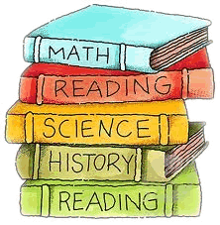

Welcome back, it’s April SBMCS family! Spring is here, the flowers are blooming, the birds are singing, and the student are excited about upcoming school events & class trips. Our students are preparing to begin the fourth quarter of the school year. Let’s continue to work together and keep our students focused and continue to create enjoyable wonderful 5th grade memories.

### South Broward Montessori Charter School

**Mrs. Yolanda**

**Ms. YaShica**

Palm News

April 2024

# Opening Statement

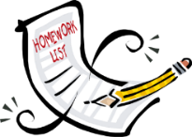

# Our Lessons

# Important Reminders

**Social Studies**: In Social Studies, 5th grade students will learn about the Southern Colonies: Part II Slavery in the Colonies,Mounting Tension in the Colonies, The Road to Revolution, The Revolutionary War, Hispanic in the Revolutionary War, Growing Pains for the New Nation, The Constitution, Plans for the New Government, The Louisiana Purchase, Early Westward Expansion, and they will also complete an Economy Project at the end of the quarter.

**Reading:** In Reading, 5th grade students will read Apply Metacognitive & Fix-Up Strategies to Build Knowledge about Oceans, and The Economic Development of Cities. Then the students will continue to learn how to analyze how the story elements contribute to meaning and tone, analyze characters, conflict, & theme, they will analyze characters in a literary text, analyze literary texts with similar themes, and analyze literary texts with similar themes. The students will also explain the development of themes.

**Language:** We will work with different types of reading themes; the students will create their own story. The students will practice their reading comprehension. They will also, practice their writing skills and comprehension.

**Writing:** In writing, 5th grade students will work on writing a Research Report, Multimedia Presentations, a Cinquain, a Diamante Poem, and Opinion Writing/Share writing. In language, students will work with Adjective Suffixes: -y, -ent, - ive -ic, -ful, Prefixes (re-, bio-, im- ex-, micro-), and Science Roots (se, mech, cycle, phys, chem). In grammar in context: Using Conjunctions to Begin a Sentence.

**Science:** In Science, 5th grade students will review Forces of Motion: Push, Pull, Friction, and Magnetic Attraction/Gravity, Forces and Changes in Motion, Force Mass in Objects, The Effect of the Overall Forces on Motion, Properties of Matter, Separating Mixtures and forming Solutions, The Effects of Temperature on Physical and Chemical Changes, Classification of Plants and Animals, Environmental changes Vs. Population Size, The Flow of Energy in a Food Chain, and along with weekly experiments.

**Mathematics:** In Math, 5th grade students will Identify and Classify Three Dimensional Figures, Find Perimeter and Area, Understand Volume, Find Volume Using, Unit Cubes, Find Volume Using Formulas, Find Volume of Composite Figure, Math in Action: Work with Geometric Figures, and Additional Fluency Practice.

**Important Reminders:**

* **Students have P.E Mondays and Fridays. On these days, please have students in correct P.E. uniform*(s).***
* **Please provide students with bottle of water daily for proper hydration.**

**Homework: All students need to complete 30 minutes of I-ready every day. They are also required to complete the Spelling, Reading, and Math homework daily.**

**Request: We are looking for volunteers to donate white printer paper, case*(s)* of water, and the school needs volunteers.**



## Upcoming Events

|  |  |
| --- | --- |
| | **04/02** – Report Cards Issued  **04/19** – Career Day  **04/25** – Take your child to work day.  **04/27** – Family Fun Field Day (at our school) | | --- | |

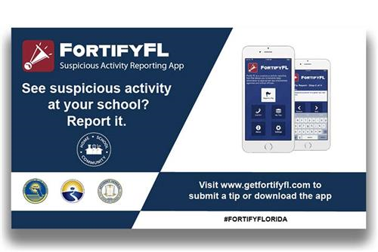

**Ms. Yolanda:**

[**ycruz@sbmontessoricharter.com**](mailto:ycruz@sbmontessoricharter.com)

**Ms. YaShica:**

[**ythall@sbmontessoricharter.com**](mailto:ythall@sbmontessoricharter.com)

In **Social Studies**, 5th graders are learning about Hispanic Heritage. Their important celebrities and their culture.

In **Reading**, the 5th level students will be working on the story from Journeys Unit 1 Lesson 6-7 comparison stories.

In **Biology**, we will be learning about the parts of a fruit, the biological evolution of life and we will begin to study the fish.

Our **Cosmic** curriculum will be focusing on how matter and energy came together to form stars, atoms, and galaxies. We will be learning about constellations, planets and continue with the timeline of the Universe.

In **Language**, we will be working with types of verbs and learning their tenses, as well as how to form and use regular and irregular verbs. They will learn that words make phrases, phrases make sentences, and sentences make paragraphs.

In **Writing**, we are following our Writing City curriculum to teach the writing cycle.

**Mathematics,** 5th graders will be working on multiplication and division facts, as well as word problems.